|  |  |  |
| --- | --- | --- |
| **Tech Saksham**  Final Project Report  **FULL STACK WEB DEVELOPMENT** |  |  |

**“Blog Management System”**

**“CMR Engineering College”**

|  |  |
| --- | --- |
| **ROLL NO** | **NAME** |
| 208R1A0415 | Hanumanthu Jhansi |
| 208R1A0423 | Katragadda Sai Divya Sri |
| 208R1A0436 | Munikuntla Kusuma |

|  |  |
| --- | --- |
| Trainer Name | Ankit Dixit |

**ABSTRACT**

In the digital age, blogging has become a ubiquitous means of communication, allowing individuals and organizations to share ideas, insights, and information with a global audience. The Blog Management System (BMS) presented in this abstract is a comprehensive software solution designed to streamline the process of creating, organizing, and publishing blog content.

The Blog Management System addresses the challenges faced by bloggers and content creators in maintaining an online presence effectively. It offers an intuitive and user-friendly interface that simplifies content creation, editing, and formatting. With integrated media management tools, users can seamlessly incorporate images, videos, and other media into their posts.

One of the key features of the BMS is its robust content organization capabilities. Bloggers can categorize and tag their posts, making it effortless for readers to discover relevant content. The system also provides advanced SEO tools to optimize blog posts for search engines, enhancing visibility and reach.

User collaboration is facilitated through multiple role options, allowing for authors, editors, and administrators with varying levels of access. Scheduling features enable bloggers to plan and automate post publication, ensuring consistent content delivery to their audience.

The Blog Management System doesn't stop at content creation; it extends to engagement with readers. A commenting system encourages interaction, and social media integration simplifies the sharing of posts across various platforms.

Security is paramount in the BMS, with measures in place to protect against spam, unauthorized access, and data loss. Regular backups and recovery options provide peace of mind to bloggers, safeguarding their valuable content.

In addition to enhancing the user experience, the Blog Management System empowers bloggers with insightful analytics. Real-time data on blog traffic, user behavior, and performance metrics enable bloggers to make data-driven decisions to improve their content and engagement.

As the digital landscape continues to evolve, the Blog Management System stands as an indispensable tool for bloggers, content creators, and organizations seeking to establish a meaningful online presence. With its comprehensive suite of features and user-focused design, the BMS is poised to redefine the way content is managed and shared in the digital world.

Furthermore, the system incorporates search engine optimization (SEO) tools to enhance the discoverability of blog posts and encourages reader engagement through a built-in commenting system. It simplifies content scheduling, supports multiple user roles, and offers detailed analytics to help bloggers understand their audience.

The Blog Management System empowers bloggers to focus on their passion for storytelling and knowledge sharing, knowing that the technical aspects of content management are handled efficiently and effectively. This project aims to contribute to the digital content landscape by providing a platform that encourages creativity, collaboration, and meaningful interactions between creators and their audience.

**INDEX**

|  |  |  |
| --- | --- | --- |
| **Sr. No.** | **Table of Contents** | **Page No.** |
| 1 | Chapter 1: Introduction | 1 |
| 2 | Chapter 2: Services and Tools Required | 3 |
| 3 | Chapter 3: Project Architecture | 4 |
| 4 | Chapter 4: Architecture Blocks Detail Working | 5 |
| 5 | Chapter 5: Project Budget | 6 |
| 6 | Conclusion | 7 |
| 7 | References | 7 |
| 8 | Code | 7 |

**CHAPTER 1**

**INTRODUCTION**

* 1. **Overview**

The Blog Management System is a web application that streamlines blog creation and management. It offers features like text editing, media integration, SEO tools, and user engagement features. It simplifies content scheduling and analytics, allowing bloggers to focus on content creation. This system enhances the digital content landscape, fostering creativity and audience interaction.

* 1. **Features**
* User-Friendly Content Creation
* Easy Text Formatting
* Multimedia Integration
* Content Categorization
* SEO Tools
* User Role Management
  1. **Advantages**
* Efficiency: Simplifies content creation and management.
* User-Friendly: Easy for bloggers of all levels.
* SEO Boost: Improves content discoverability.
* Engagement: Enhances reader interaction.
* Security: Protects against threats.
* Responsive: Ensures usability on all devices.

* 1. **Scope**
* Widespread Adoption: Suitable for bloggers, businesses, and organizations.
* Content Diversity: Supports various types of content.
* Global Reach: Accessible to a broad audience.
* Continuous Improvement: Potential for feature enhancements.
* Integration: Can be integrated with other systems.
* Education: Used for online courses and tutorials.
* E-commerce: Supports content marketing for products.
  1. **Future Work**
* AI Integration: Implement AI for content recommendations.
* Block chain Security: Explore block chain for data security.
* Voice and Video: Incorporate voice and video content.
* Real-time Collaboration: Enhance collaboration features.
* AR/VR Support: Enable immersive content experiences.

**CHAPTER 2**

**SERVICES AND TOOLS REQUIRED**

**2.1 Services Used**

**2.1.1 Liberty Profile**

Used as the lightweight, efficient application server for hosting the Blog Management System. It provides essential server capabilities while conserving system resources and offering quick deployment and scaling options.

**2.2 Tools and Software used**

**2.2.1 Visual Code Studio**

Visual Studio Code (VS Code) is a popular and powerful code editor developed by Microsoft. It's known for its simplicity, speed, and extensive extension ecosystem. Here are some common use cases for VS Code.

**2.2.2 HTML**

HTML, or Hypertext Markup Language, is the standard markup language used to create web pages. It defines the structure and content of a web page by using a set of elements or tags, each serving a specific purpose.

**2.2.3 Client-side JavaScript**

Client-side JavaScript refers to the use of JavaScript code that is executed on the client's web browser rather than on the web server.

**CHAPTER 3**

**PROJECT ARCHITECTURE**

**3.1 Architecture**

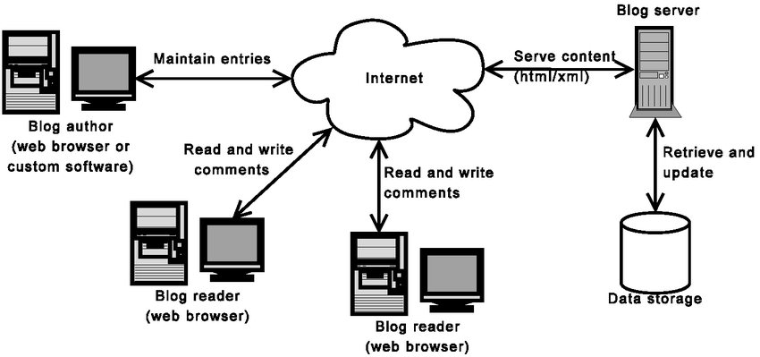

**CHAPTER 4**

**ARCHITECTURE BLOCKS DETAIL WORKING**

**4.1 Blocks**

**Blog Author (Content Creator):**

A figure representing a blog author (a person or user icon).

Label: "Blog Author."

**Blog Server:**

A rectangular box representing the blog server.

Label: "Blog Server."

Arrow to/from Blog Author and Data Storage.

**Data Storage (Database/File System):**

A rectangular box representing the data storage.

Label: "Data Storage."

Arrow to/from Blog Server.

**Blog Reader (Web Browser):**

A figure representing a web browser icon or user icon.

Label: "Blog Reader (Web Browser)."

Arrow to/from Blog Server.

**CHAPTER 5**

**PROJECT BUDGET**

It won’t cost anything for our project. But if anyone want to use this project for commercial purpose the budget could be as follows:

|  |  |  |  |
| --- | --- | --- | --- |
| **Sr. No** | **Cloud Services and Coding Cost** | **Single Price (Rs)** | **Total** |
| 1. | Development Cost | 1000/- | 1000/- |
| 2. | Hosting | 500/- | 500/- |
| 3. | Marketing | 700/- | 700/- |
| Total | | | 2,200/- |

**CONCLUSION**

The Blog Management System offers a comprehensive solution to the challenges faced by bloggers and content creators. By streamlining content creation, optimizing for SEO, enhancing user engagement, and simplifying the publication process, it empowers users to efficiently manage their digital content. The system's modular architecture and thorough deployment ensure reliability and scalability.

To ensure the success of the project, careful planning, resource allocation, and continuous monitoring of expenses are essential. Additionally, it's crucial to factor in potential marketing and promotion costs, which can vary greatly based on the desired reach and impact of the blog.

Ultimately, a well-executed Blog Management System can provide a platform for efficient content creation and management, engagement with readers, and the potential for revenue generation. By aligning the budget with project goals and priorities, you can create a sustainable and successful blog management system that meets your specific needs and objectives.

**REFERENCES**

* <https://github.com/topics/blog-management-system>
* <https://dev.to/themodernweb/fullstack-how-to-create-a-working-blogging-website-with-pure-html-css-and-js-in-2021-9di>

**CODE**

**Git Hub Repo Link:**

**https://github.com/Kusuma436/TSP-TEAM-54**